**Step 1 :** **Create a New Job**

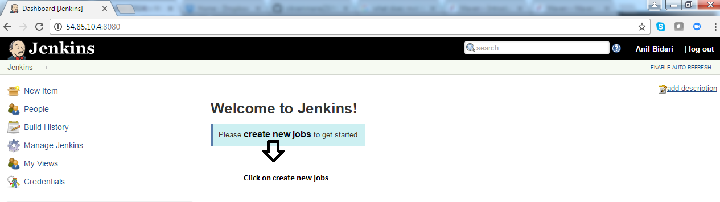

**Step 2 :** **Name the job as “project-git”**

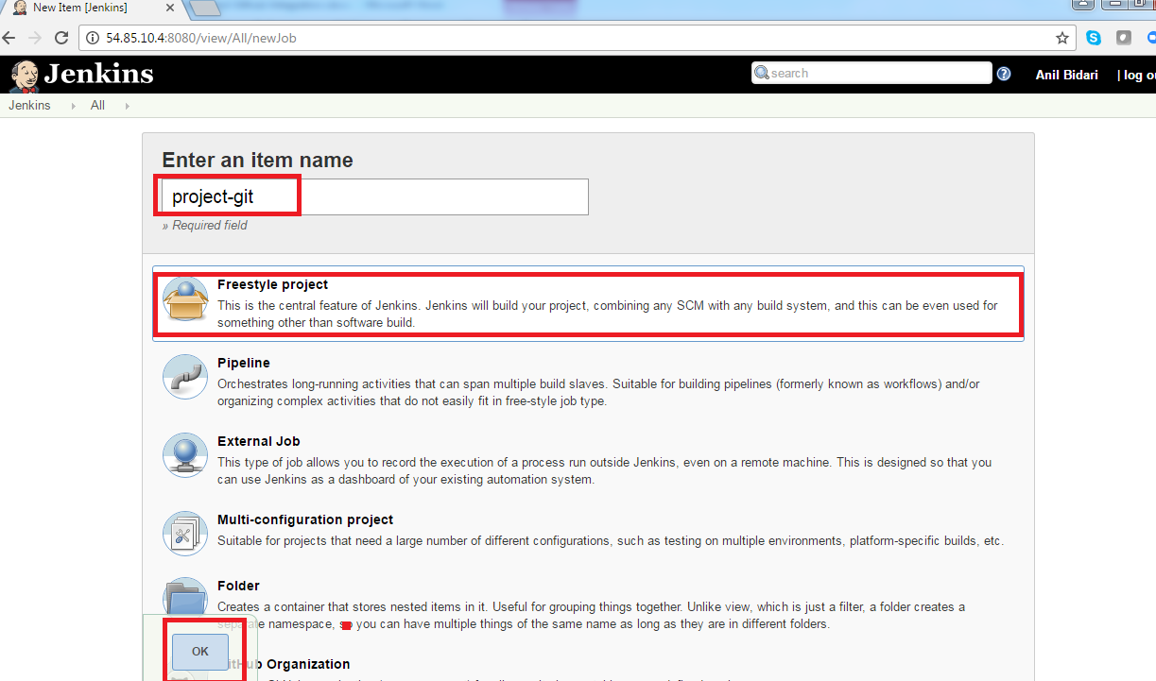

**Step 3.A :** **Click on Source code management**

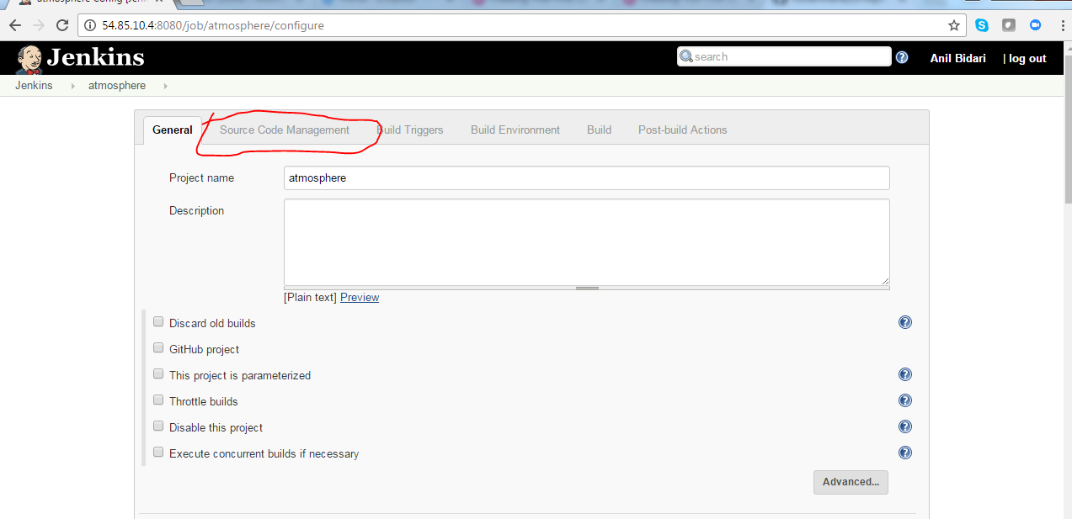

**Step 3.B :** **Provide the git repository source url**

<https://github.com/cloudenabled4/public-repo.git>

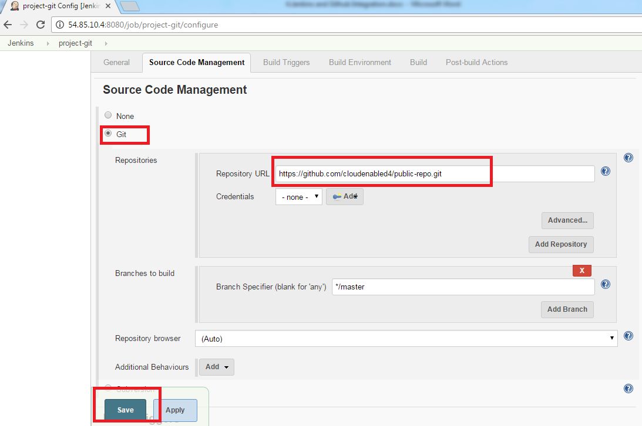

**Step 4 :**  **You will redirected your job summary page ,click on “Build now”**

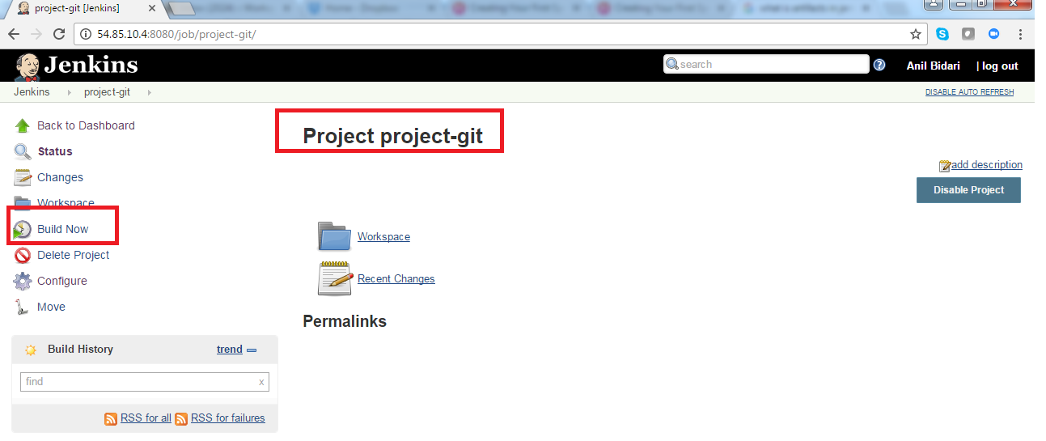

**Step 5 :**  **Under build history ,click on “#1” your first build**

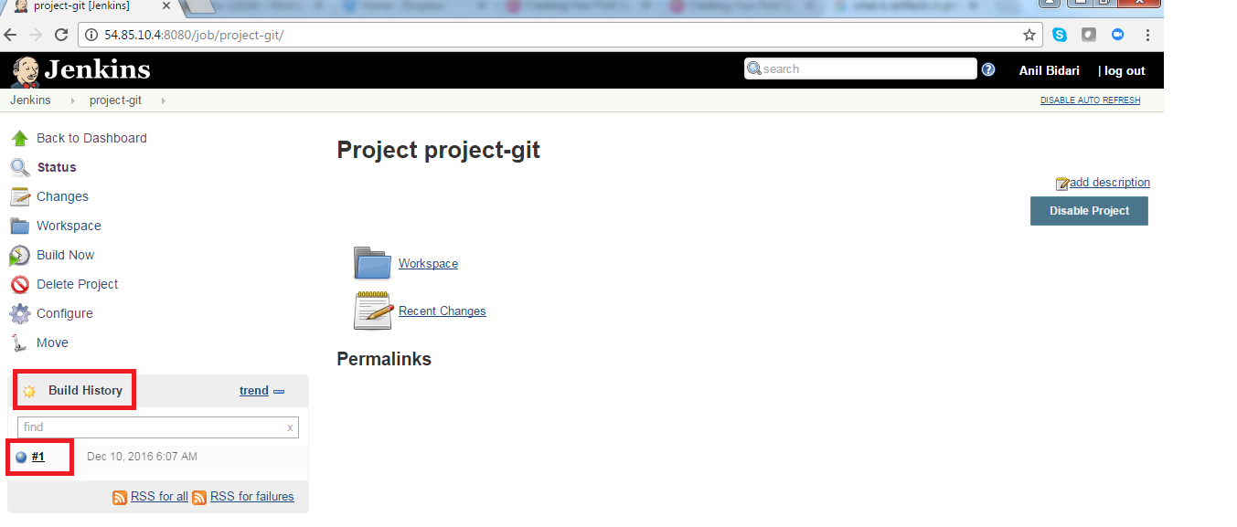

**Step 6 :**  **Click on “console output”**

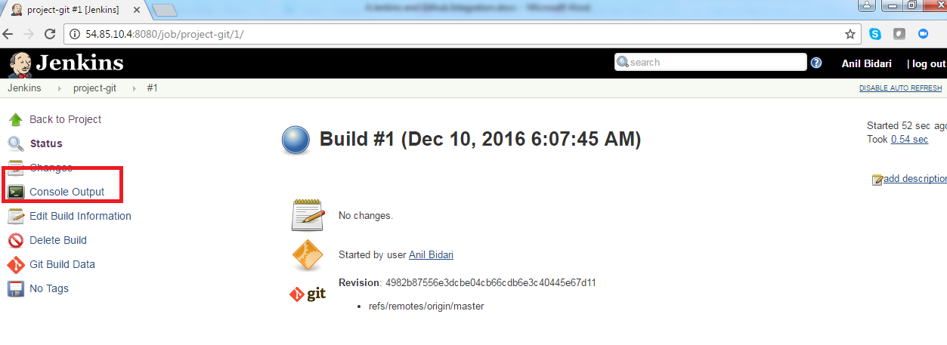

**Step 7 :**  **Observe the output, you can note where the code is getting cloned**

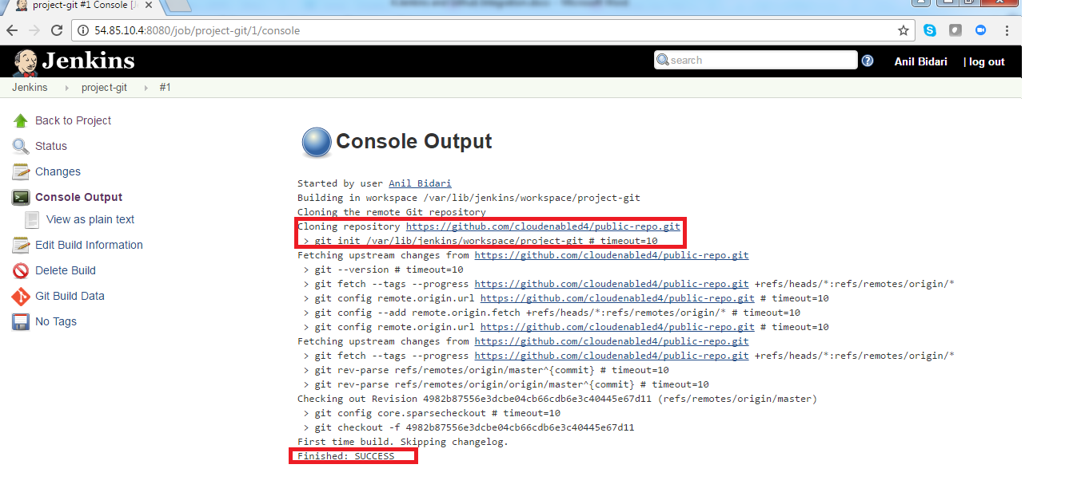

**Step 9 :**  **Ssh to your Jenkins server and verify in your Jenkins folder**

cd /var/lib/jenkins/workspace/project-git

ls -l

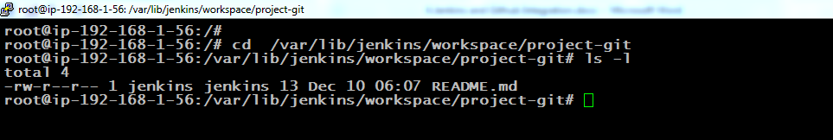

**Step 10 :**  **Go to your github and edit your readme file of public-repo**

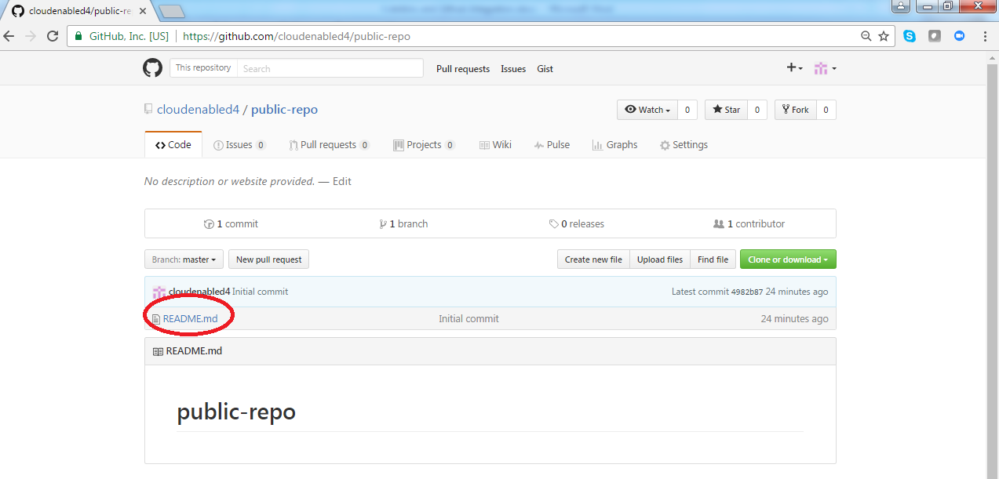

**Next step :**  **Go to your github and edit your readme file of public-repo**

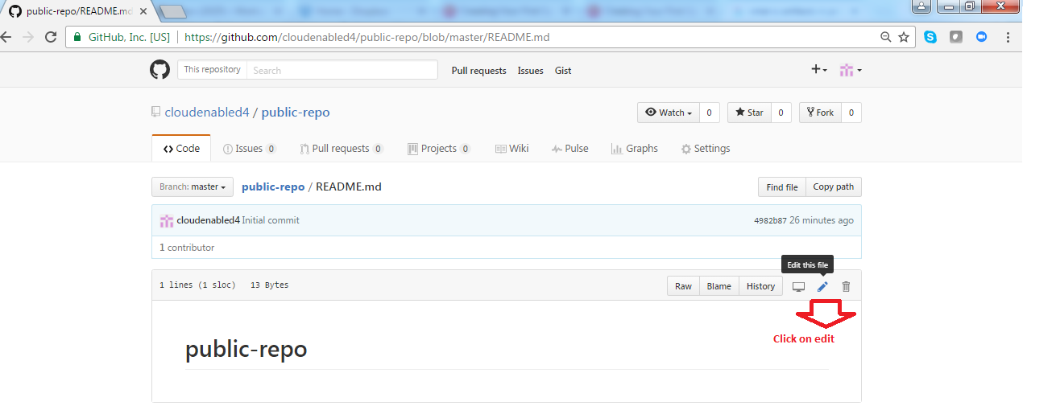

**Next step :**  **Add below line and commit changes**

I am adding line number 02

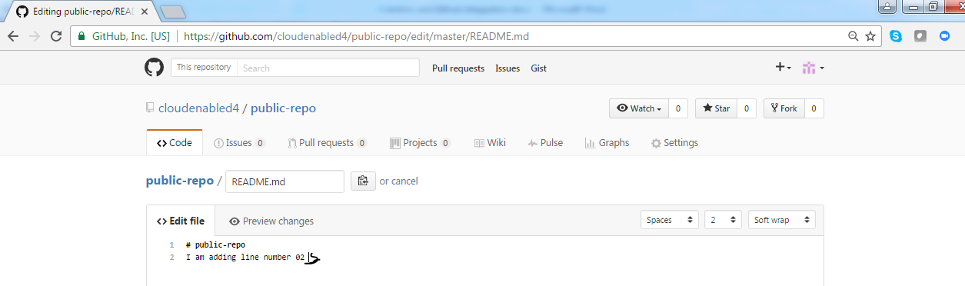

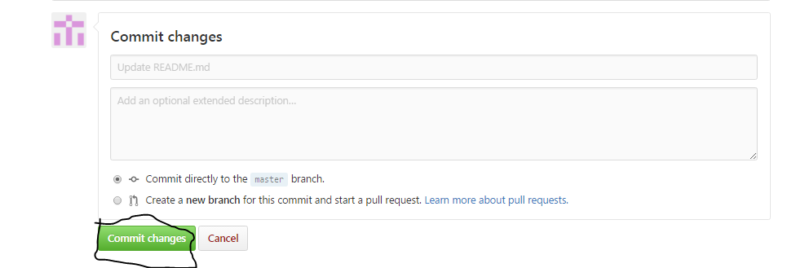

**Next step :**  **Go back to Jenkins dashboard**

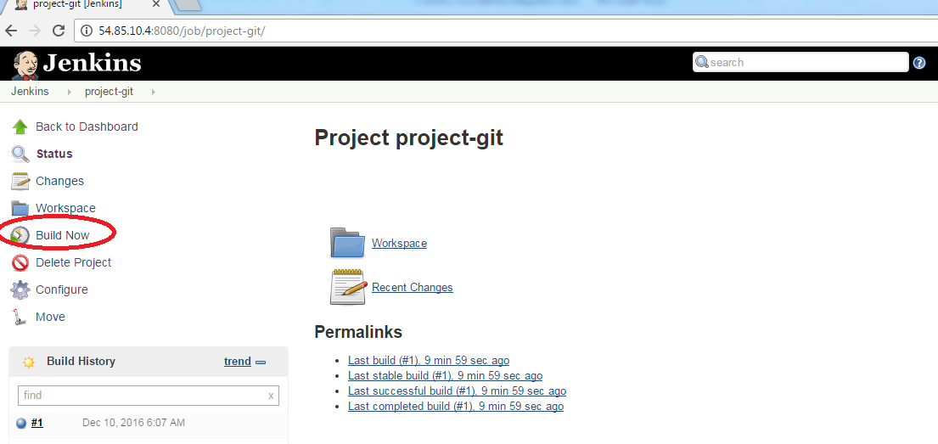

**Next step :**  **Click on your “build #2”**

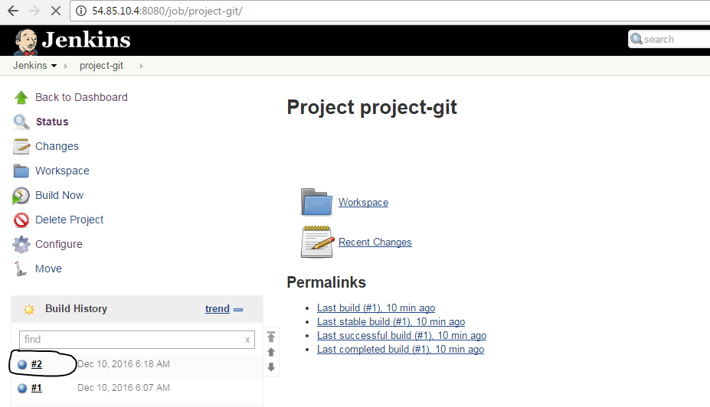

**Next step :**  **You can notice changes have been identified by Jenkins**

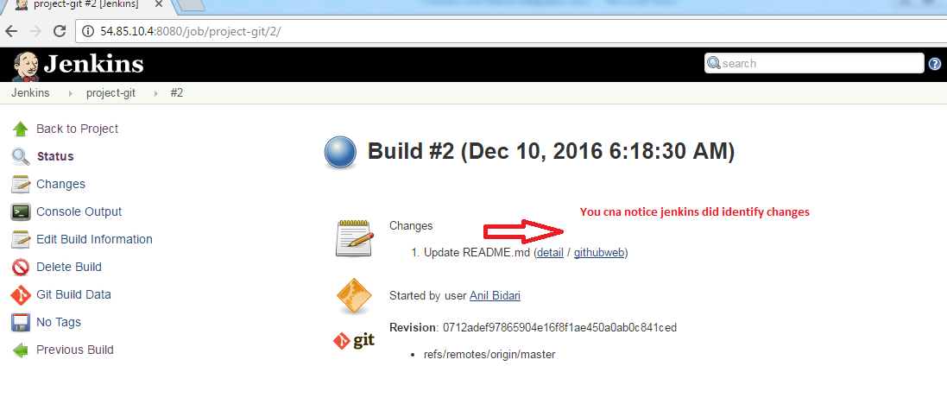

**Next step : Click on gitweb**

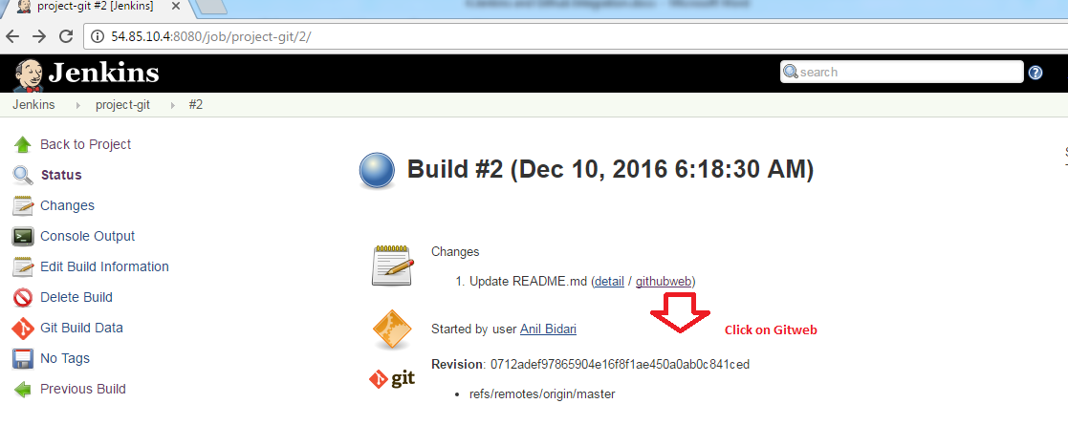

**Next step : Observe the change**

